

Name: Karan Kumar Pal
PRN: 25070122098
Branch: CSE (2025-29)
Semester: 3
Subject: Programming with Java

ASSIGNMENT No.: 2
TITLE: :Develop a Java application demonstrating the use of default, parameterized, and copy constructors for object initialization and data management.

Problem Statement:
Develop a Java application demonstrating the use of default, parameterized, and copy constructors for object initialization and data management.

Learning Objectives:
To understand and implement default, parameterized, and copy constructors for object initialization.

Theory:
Constructors are special member functions that are automatically invoked when an object is created.
Java supports default constructors provided by the compiler, parameterized constructors for initializing objects with user-defined values, and copy constructors (implemented manually) for creating duplicate objects. Constructors improve code readability and simplify object initialization while supporting object-oriented programming principles.

Outcomes:

- Default Constructor

CODE

class Student{ String name; int age;

Student(){
name = "Abel"; age = 19;
}

void display(){
System.out.println("Name:" + name + ", Age:" + age);
}

}

public class demo{
public static void main(String[] args){ Student student1 = new Student(); student1.display();
}
}

OUTPUT

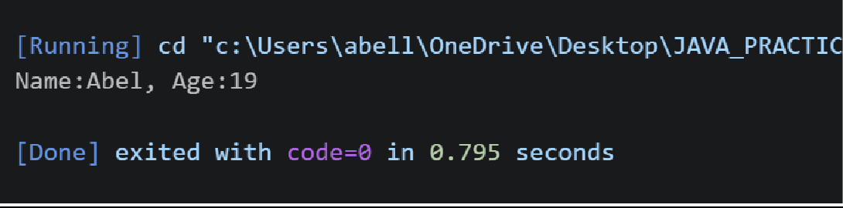

Parametrized Constructor

CODE

class Student{ String name; int age;

Student(String n,int a){ name = n;
age = a;
}

void display(){
System.out.println("Name:" + name + ", Age:" + age);
}

}

public class demo{
public static void main(String[] args){ Student student1 = new Student("John",20); student1.display();
}
}

OUTPUT

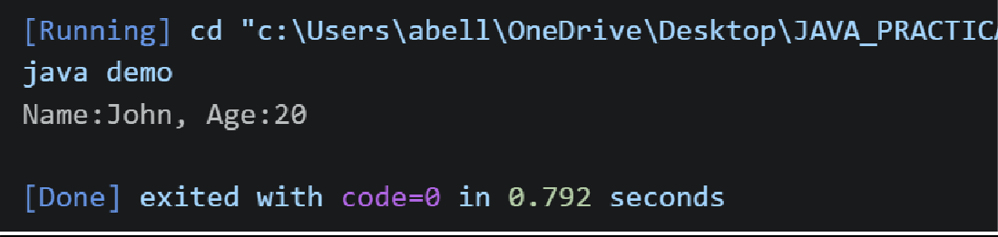

Copy Constructor

CODE

class Student{ String name; int age;

Student(String n,int a){ name = n;
age = a;
}

Student(Student s){ name = s.name; age = s.age;
}

void display(){
System.out.println("Name:" + name + ", Age:" + age);
}

}

public class demo{
public static void main(String[] args){ Student student1 = new Student("David",20); Student student2 = new Student(student1);

student1.display(); student2.display();
}
}

OUTPUT

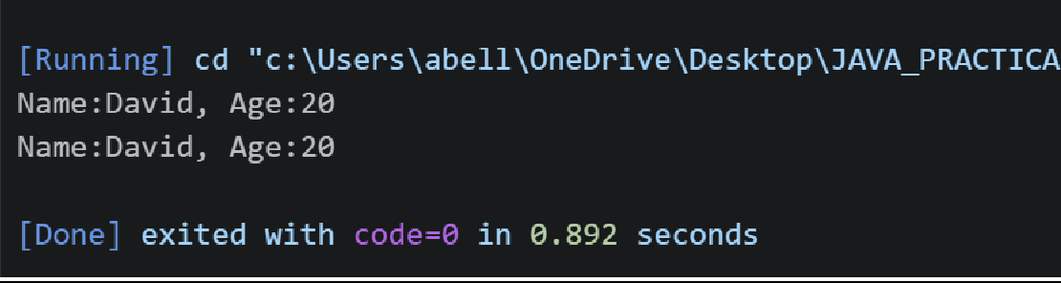

Conclusion:

This program demonstrates the use of constructors in Java through the Student class. The default constructor assigns fixed values, the parameterized constructor allows custom student data, and the copy constructor creates a new object using an existing student's values. Together, they show how object initialization can be handled flexibly in Java.

Exercise:

- Create a Student class using default and parameterized constructors to initialize student name and roll number.
class Student{ String name; int rollNo;

// default constructor Student(){
name = "Not Assigned"; rollNo = 0;
}

// parameterized constructor Student(String n, int r){
name = n; rollNo = r;
}

void display(){
System.out.println("Name:" + name + ", Roll No:" + rollNo);
}
}

public class demo{
public static void main(String[] args){ Student student1 = new Student();
Student student2 = new Student("Abel", 101);

student1.display(); student2.display();
}
}

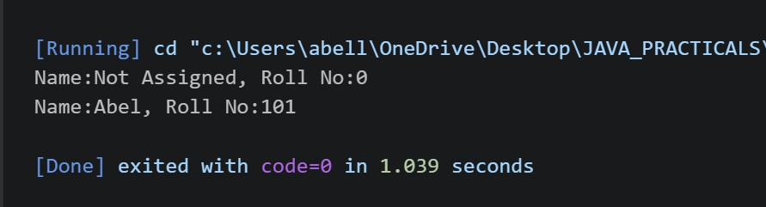

- Develop a Mobile Phone Inventory System using different constructors to initialize mobile details and create duplicate object records.

class Mobile{
String brand; String model; double price; int quantity;

Mobile(){
brand = "Not Assigned"; model = "Not Assigned"; price = 0.0;
quantity = 0;
}

Mobile(String b, String m, double p, int q){ brand = b;
model = m; price = p; quantity = q;
}

Mobile(Mobile m){ brand = m.brand; model = m.model; price = m.price;
quantity = m.quantity;
}

void display(){
System.out.println("Brand: " + brand + ", Model: " + model + ", Price: " + price + ", Quantity: " + quantity);
}
}

public class demo{

public static void main(String[] args){
Mobile mobile1 = new Mobile();
Mobile mobile2 = new Mobile("Samsung", "Galaxy S24", 79999.0,15); Mobile mobile3 = new Mobile(mobile2);
mobile1.display(); mobile2.display(); mobile3.display();
}
}
